**Pivot-ED Assessment 3 Teddy Aigbedion**

From the foregoing, this assessment is somewhat pinned on Data Manipulations. Having mentioned that, it is considered important from my opinion to define the term Data Manipulation

**DATA**: Data is important to human existence and decision-making process as Oxygen is to Human beings, apparently data have played a very important role from time immemorial which range from aiding record keeping that have shaped histories in variant cultures and belief systems to assisting in human civilization. Data indeed is the catalyst that drives every discovery.

Therefore for the sake of this assessment **DATA** can be define as the smallest units of factual information that can be used as a basis for calculation, reasoning, or discussion. Data can range from abstract ideas to concrete measurements, including, but not limited to, statistics.

**DATA MANIPULATION:**

Data manipulation refers to the process of adjusting data to give it a constructive pedigree, enabling easy reading and understanding with the aim of gaining deeper insights or knowledge about the data to assist in personal or corporate decision-making. Data manipulation language or DML is a programming language that adjusts data by inserting, deleting and modifying data in a database such as to cleanse or map the data to solving a pressing issue or problem.

Having define data manipulation, let’s get into answering the assessment

**Chosen Dataset: AIRBNB**

Since we are using Python programming language to manipulate and process our data, it became imperative to first load our dataset into python and the step taken are

Since AIRBNB was an excel format, I needed to download a python module called **Openpyxl:** this module is what can enable python to read excel file when loading a dataset. As we all know pip install is the most convenient and easy way to install python modules or functionalities so below is the python code to install Openpyxl

>>> ***Python –m pip install Openpyxl | pip install Openpyxl***

Note: **pandas by default usually reads Csv files, so another easier way to load data into python using pandas is to file convert the dataset from any file format to Csv format, with this you will not need to install any other module just to load dataset. In my case I just like to explore learning different ways of doing something**

**Second Step: Data Cleaning**

After loading our dataset into python, our next task became cleaning our dataset to make sure missing values are replaced with either average, mode or a default string statement. This depends on the case in hand. Below is the python code displaying the cleaning dataset step

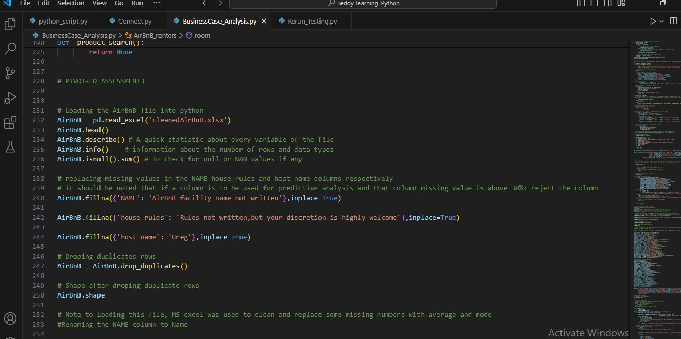

**Third Step: Setting our Python data structure to match the data type of the respective columns of our dataset**

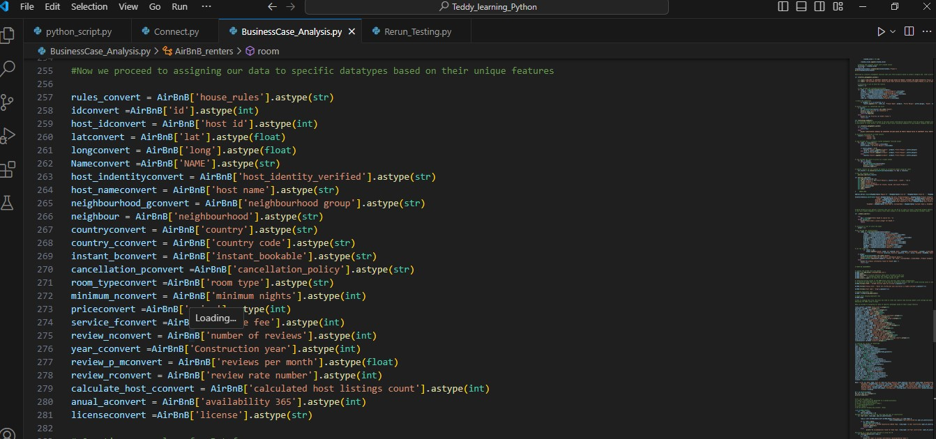After data cleaning, the next task became setting our respective columns in our dataset to the appropriate python data structure. This step is crucial because it determines how well python can analyze our dataset when we call on it functionality to solve our dataset according to the specific requirements. Below is a screenshot of the python code setting the data types making use of python data structure

**Fourth Step: Creating our column for pandas data frame**

This step will enable us to have an object table that will permeate our Class definition that will put us on the proper step to processing our dataset to suit demands of this assessment. Below is a python code for this step

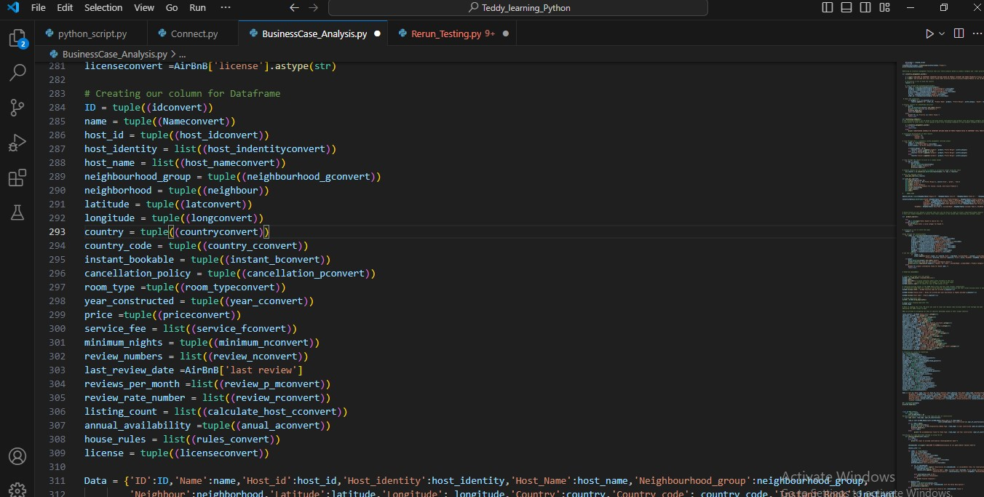

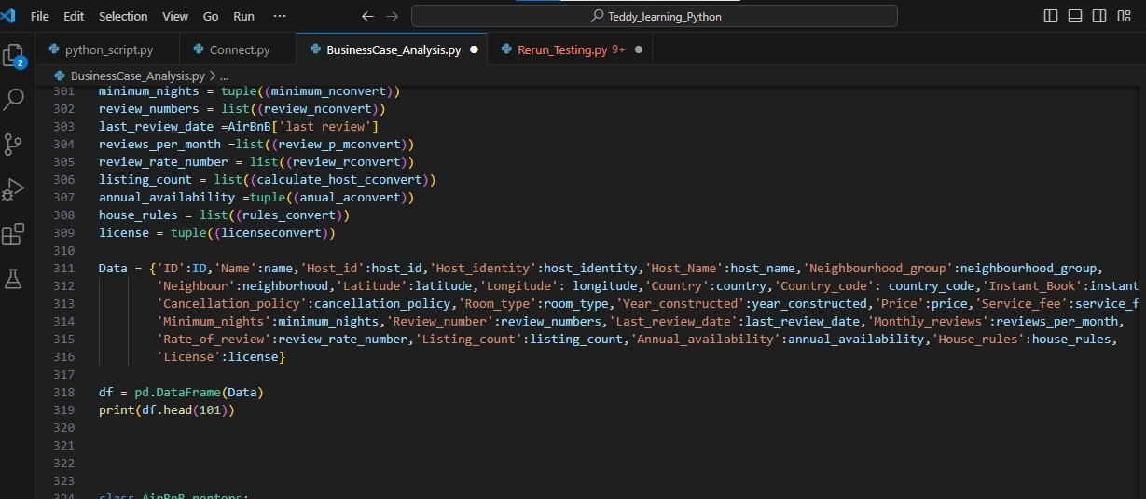

**Fifth Step: Defining our Class and methods using the pandas data frame from step four**

In this step, I defined a class AirBnB_renters: this encompasses AirBnB_renters as a business entity that is into hospitality and accommodations for their clients and with this Class definition we are able to know the facilities AirBnB_renters have in different cities to satisfy her client. Going forward we defined a method that categorize AirBnB_renters facilities based on room type and the year in which the facility where the room type located was constructed, and also defined another method that checks a client check-in ID for validation before allowing access to facility. This construction will surely informed AirBnB_renters to determine their pricing policy and also enhance confirming clients Check-in information’s thereby serving their clients much better. Below is the python code

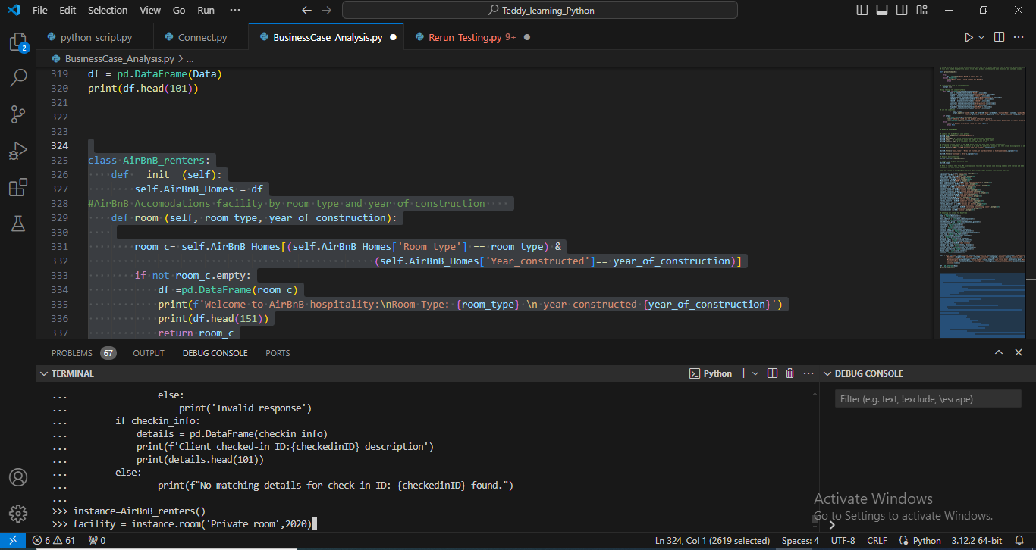

The next screenshot below of same code verifies a client check-in code or id and proceed to asking the receptionist if he/she wishes to proceed viewing the checked-in ID full information after verification or not.

